**Contribution Title (Times New Roman 14)**

Presenting Author1*, Co-Authors2

*1Departement, organization, address, city, Century.*

*2Departement, organization, address, city, Century.*

*Corresponding Autor Email:

**Abstract**

The abstract of your paper should be written in a structured manner within **250 words** limit. The abstract should be written in a single paragraph format. A high-quality abstract should give a brief overview of the paper including the purpose, the research design / methodology, and the findings. It is also good practice to explain how the findings from the research can be useful in solving problems or closing gaps in the specific subject area.

***Keywords****: Up to 3 keywords should be provided in alphabetical order separated by commas.*

1. **Introduction**

The starter section should provide a synopsis of the article as well as the background and context of the paper. Starting from general to the specifics, this section should provide a rationale that substantiates the research. This can be done by providing evidence of difficulties that needs solution and/or identified knowledge gap in a specific domain, level, geographical location, society, and industry. As the response, a clear research agenda can be described specifying research aim and objectives to clarify the purpose of conducting the investigation.

1. **Research Methodology**

The research methodology should clearly discuss the approach and/or the research design, data collection, and data analysis adapted or to be adapted in the research. One of the most important issues to be discussed here is the appropriateness of the selected methodology, is the most appropriate choice compared to other alternatives. This is the opportunity for the authors to demonstrate their awareness and understanding (appropriate for the level of study) of the research tools commonly used in their field and how this knowledge is used to inform them in constructing a robust methodology to tackle the research problems/questions. Note that not all papers will have a formal research methodology section as some papers might be scoping papers, critical reviews, etc.

1. **Results and Discussion**

In this section, authors should thoroughly discuss all obtained results in their research papers, particularly within the discussion.

Figure captions should be centered below the figures as shown in Figure 1.

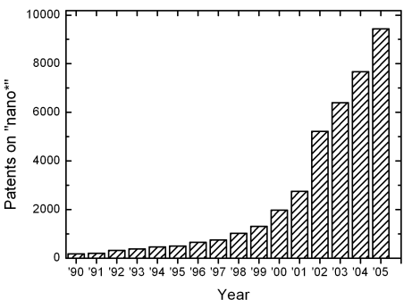

**Figure 1:** Number of patents on nanotechnology with time

1. **Conclusions and Further Research**

In this section, the author / authors should summarise the whole discussion presented in the paper. This should be done by concisely reminding the reader about the origin of the investigation and how the research has been designed and conducted, followed by the findings so far and who can benefit from the results.

**References**

[1] Proper references must be included throughout the text and the list of references must be provided in this section (use IEEE format of references)

**Page setup**

1. Paper size A4.
2. All Fonts 12pt in the full paper must be in Time New Roman 12pt only.
3. Margin is as indicated in this template (Top and Bottom 1.5 cm, Left and Right 2 cm).
4. Page limitation Authors are allowed to submit a final contribution of up to 2 pages only.